**Appendix A**

**Project Schedule and Work Assignment**

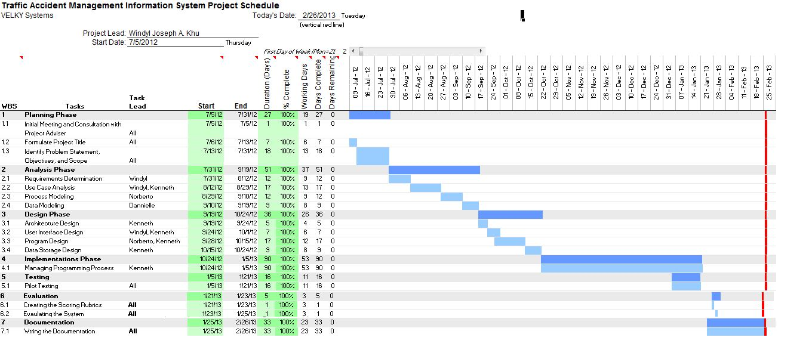

This Gantt chart illustrates the thesis schedule. The thesis started at July 5, 2012. The work breakdown structure can also be in the chart.